Activity No 2. IT Club Activity “Students Technical Talk on Cyber Security”
Title of the Event | IT Club Activity “Students Technical Talk on Cyber Security” | 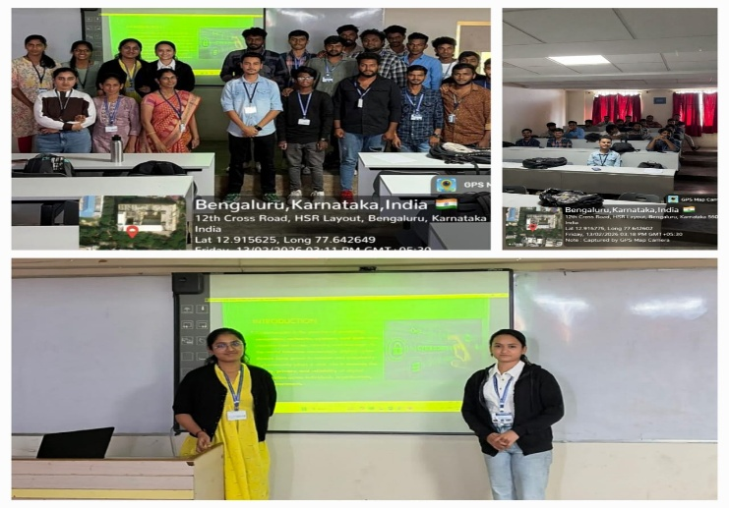
Day and Date | 13.02.2026
Venue (With all details ) | Roon No-309
In collaboration with ( if any) | -
Details of Resource Person With Designation | T.M. Kavitha | 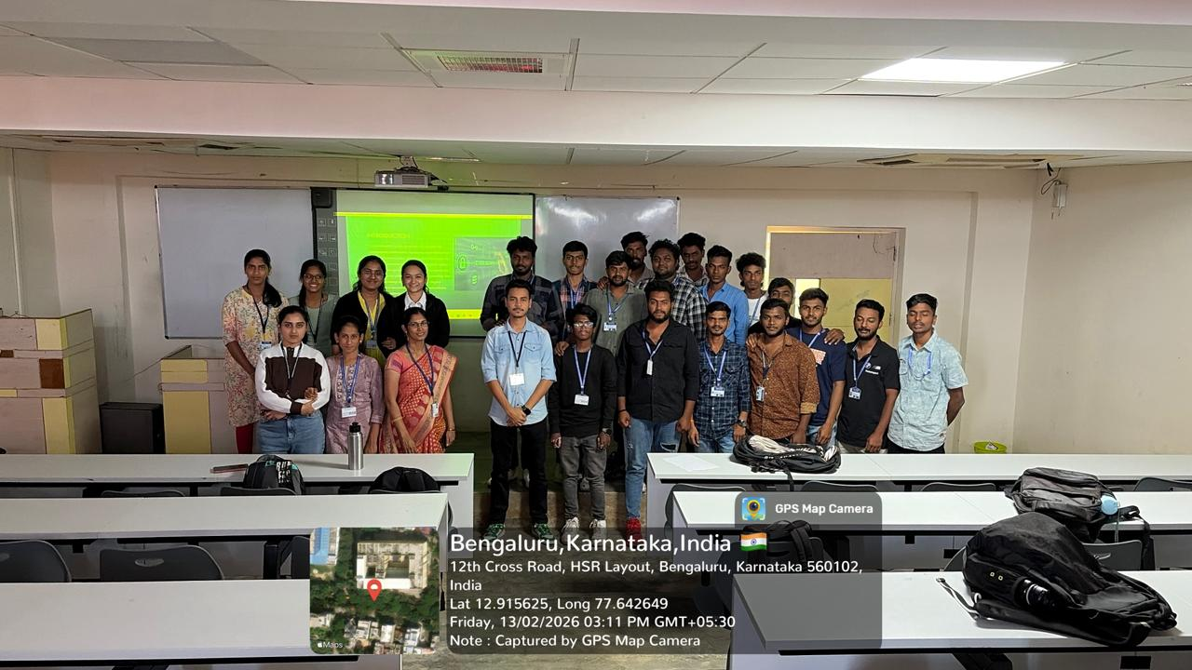
Organizing Department/Coordinators | Business Management .  T.M Kavitha
Course and semester | MBA I Semester
No of Students & Faculty Participants | 35

Coordinator HoD Vice-Principal Principal

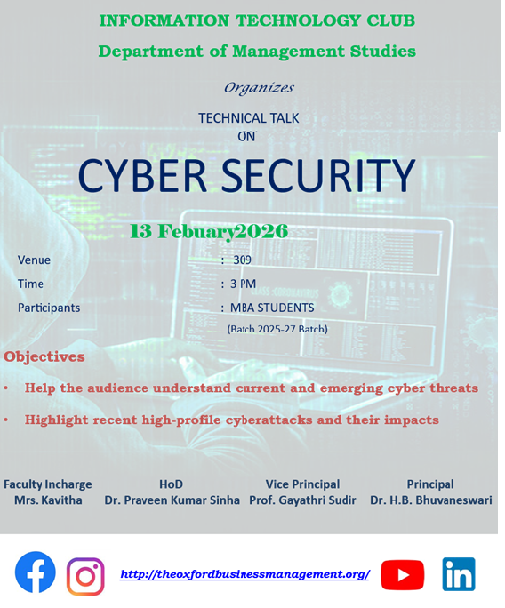

The Department of Management Studies organized an Technical talk on Cyber Security on 13-02-2026, in the Room no: 309. The event aimed to encourage awareness of current trends in Information Technology and enhance the technical knowledge among students.The session aimed to create awareness about the growing importance of cybersecurity in today’s digital world and to provide insights into the latest threats, preventive measures, and career opportunities in the field.
The main objectives of the technical talk were to spread awareness about different types of cyber threats and attacks and also to explain best practices for ensuring digital safety and data protection. It also insisted on familiarizing participants with cybersecurity tools, technologies, and strategies. The session gave a brief introduction to cybersecurity and its significance in personal and organizational life. Explanation of common cyber threats like phishing, malware, ransomware, identity theft, and social engineering were also elaborated to the participants. Discussion on preventive measures such as strong password practices, multi-factor authentication, firewalls, and encryption were by the students. Demonstration of cybersecurity tools and technologies used for monitoring and preventing attacks were also handled by the speaker. The students were encouraged to explore career paths in cybersecurity, including ethical hacking, digital forensics, and network security.
The talk was highly beneficial for the participants as it enhanced their knowledge of cybersecurity and its relevance in the modern era. Students and professionals gained awareness about how to safeguard personal and organizational data. The session also inspired many attendees to explore further studies and career opportunities in cybersecurity.

